**LIT ASSIGNMENT-DAY 12**

**NAME: CHIKATI LIKHITHA**

**EMPLOYEE ID: 46255243**

**BATCH NAME: SAP ABAP-25**

**STEP1:** GO TO SFP.

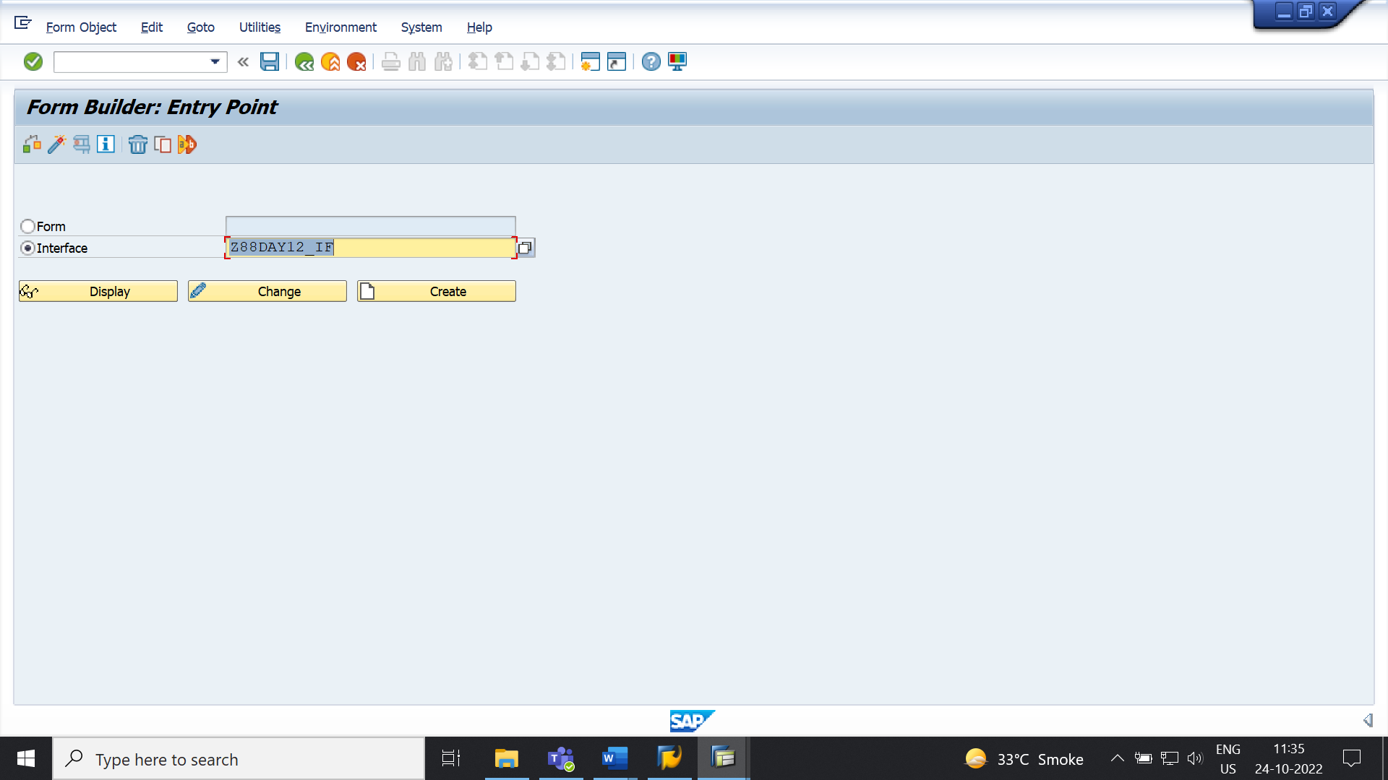

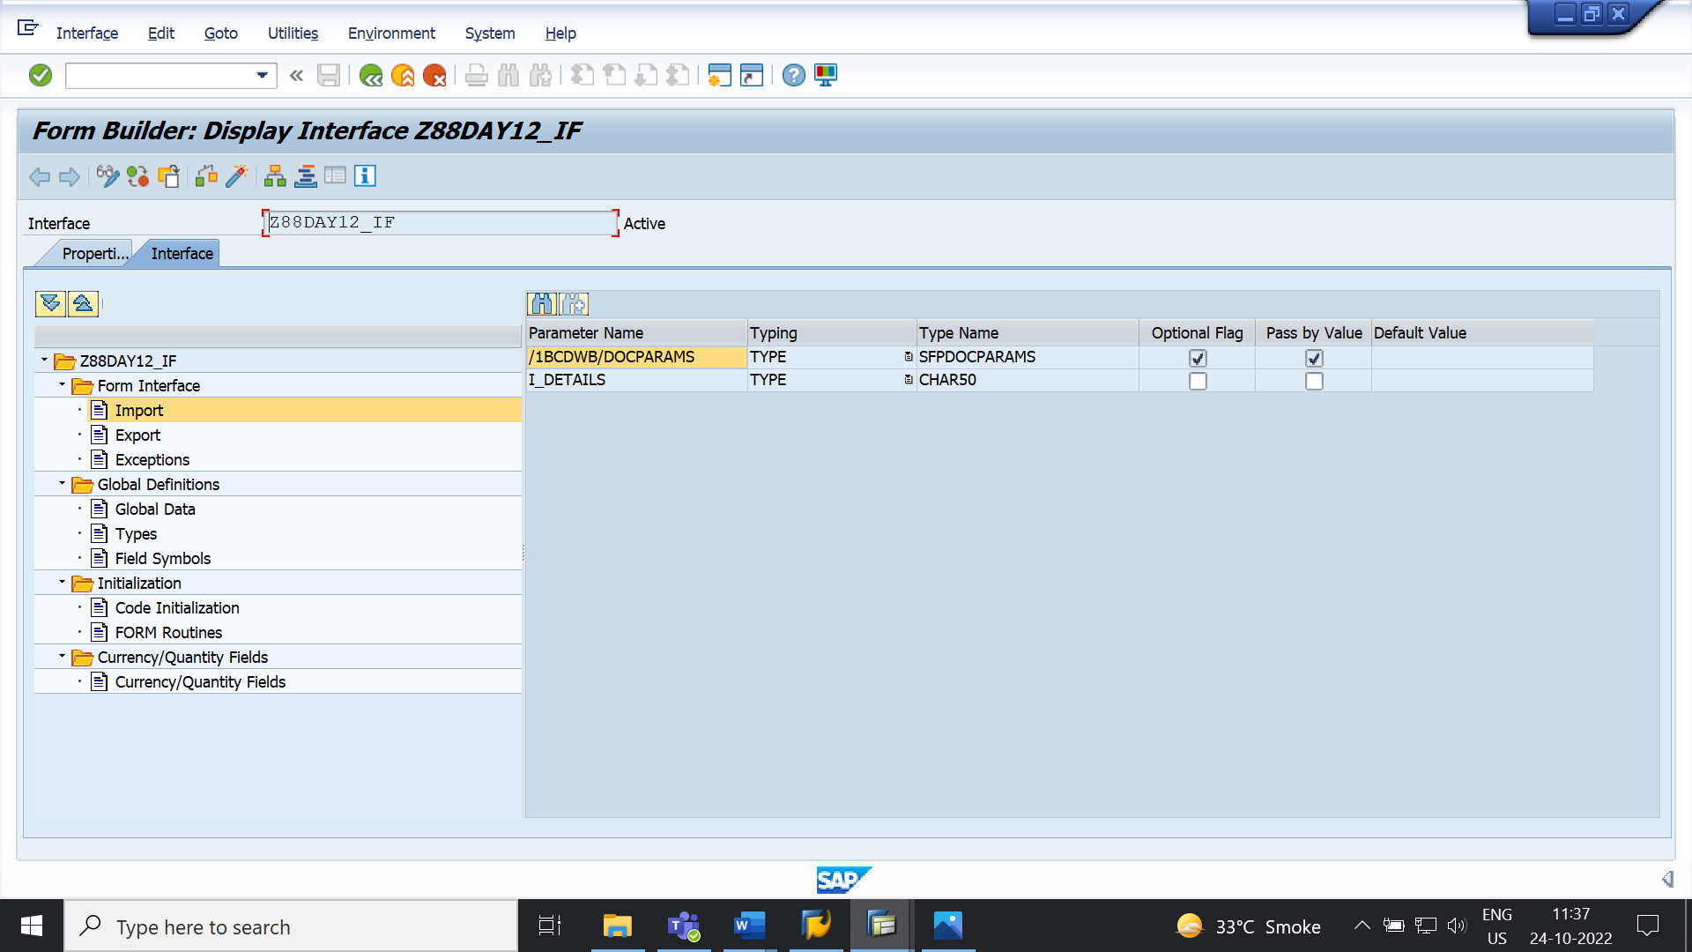

GO TO SE78

DECLARE

S_IMG FOR DATA DECLARATION

IT_TAB FOR IT_FLIGHT FIELDS DATA

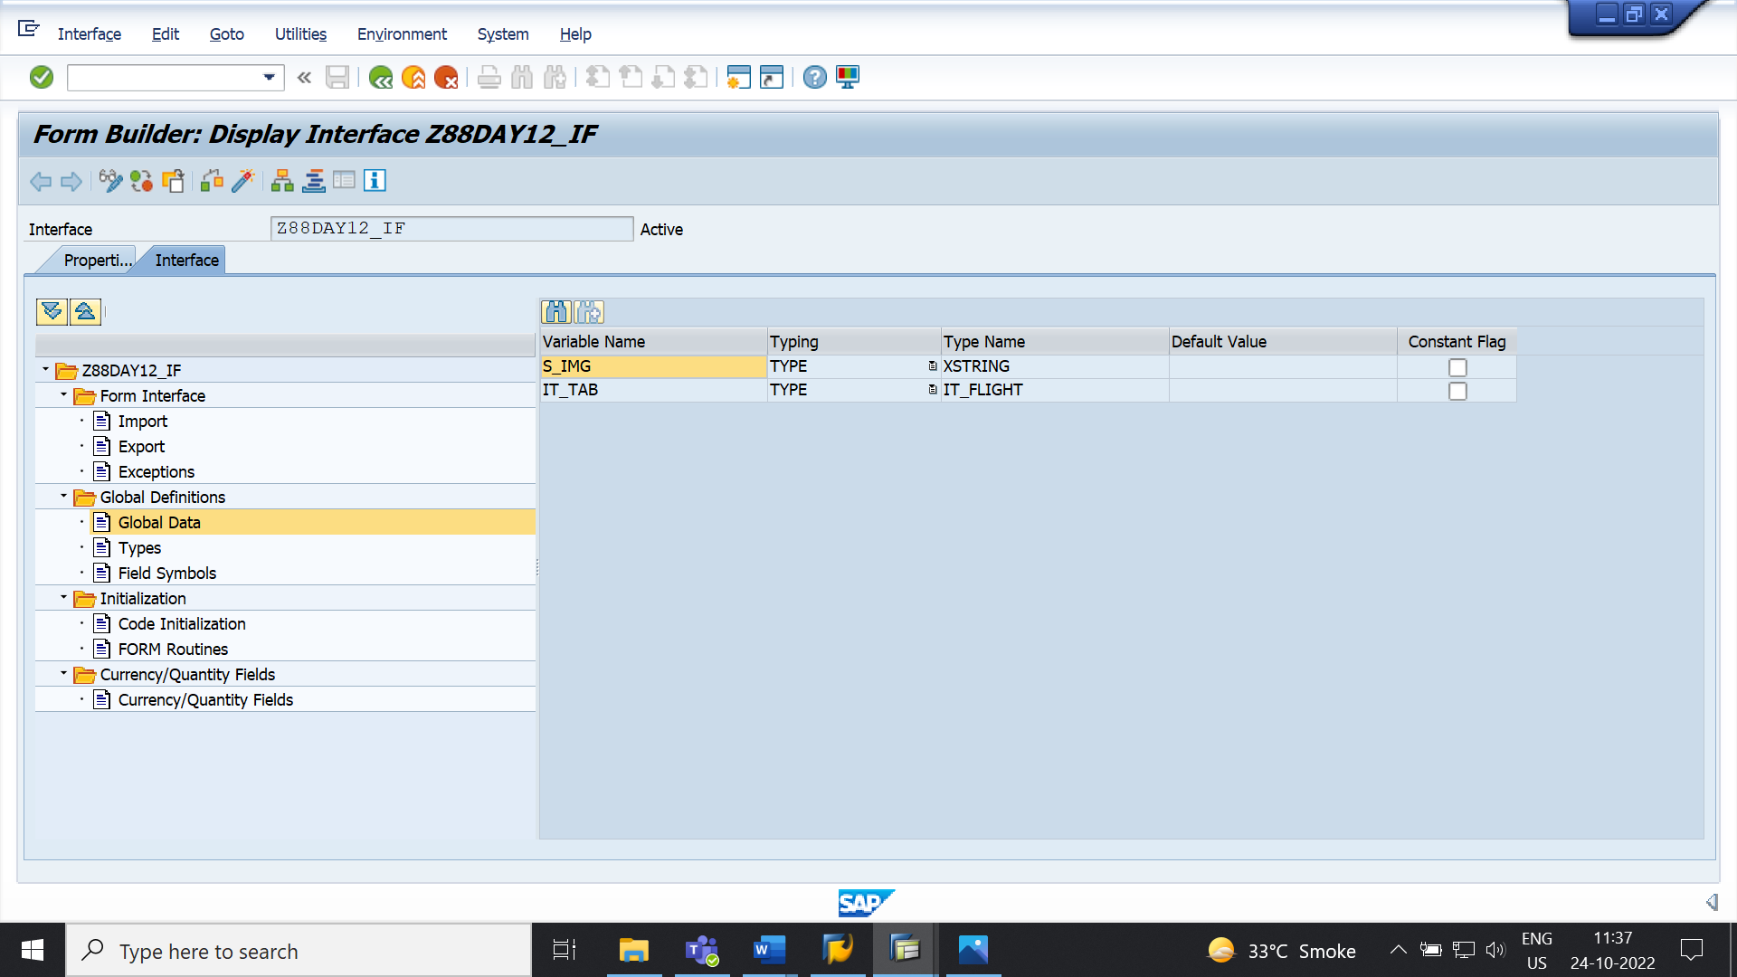

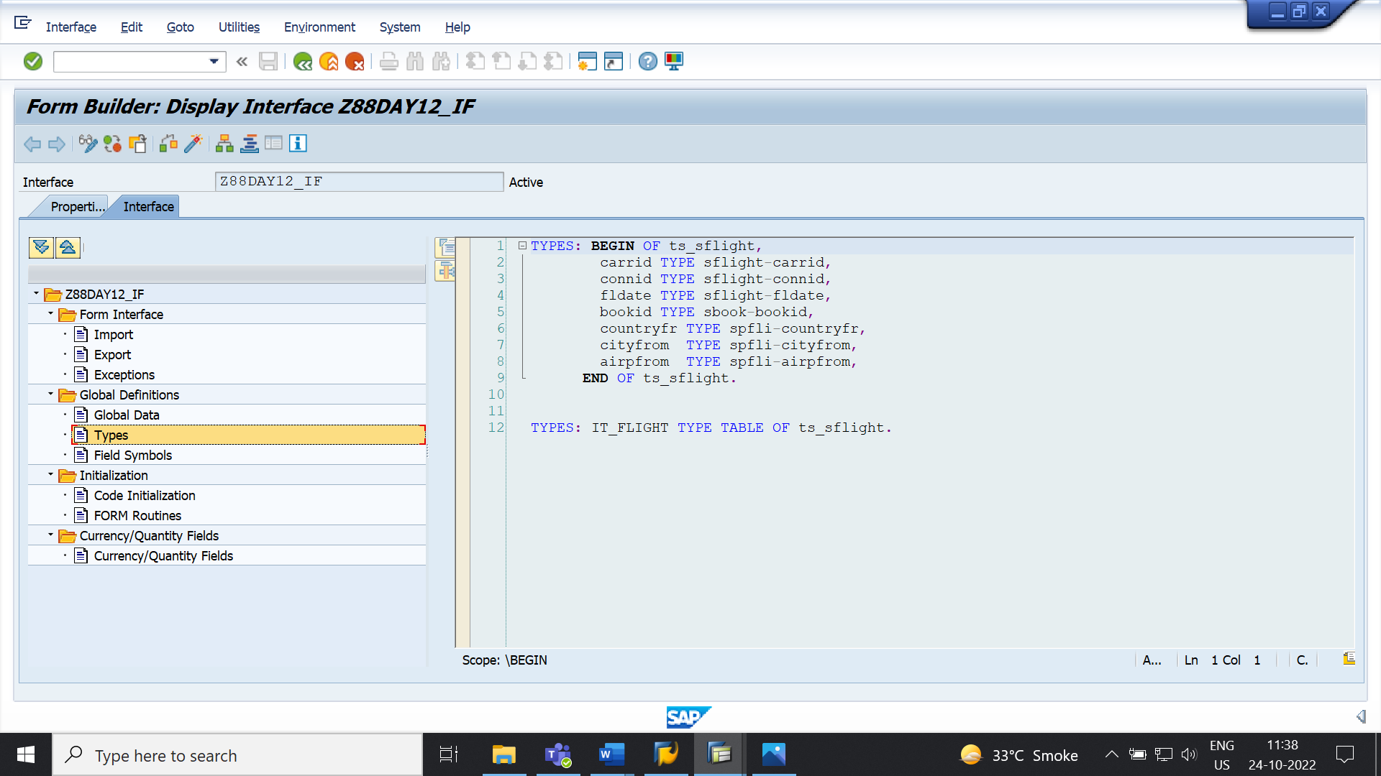

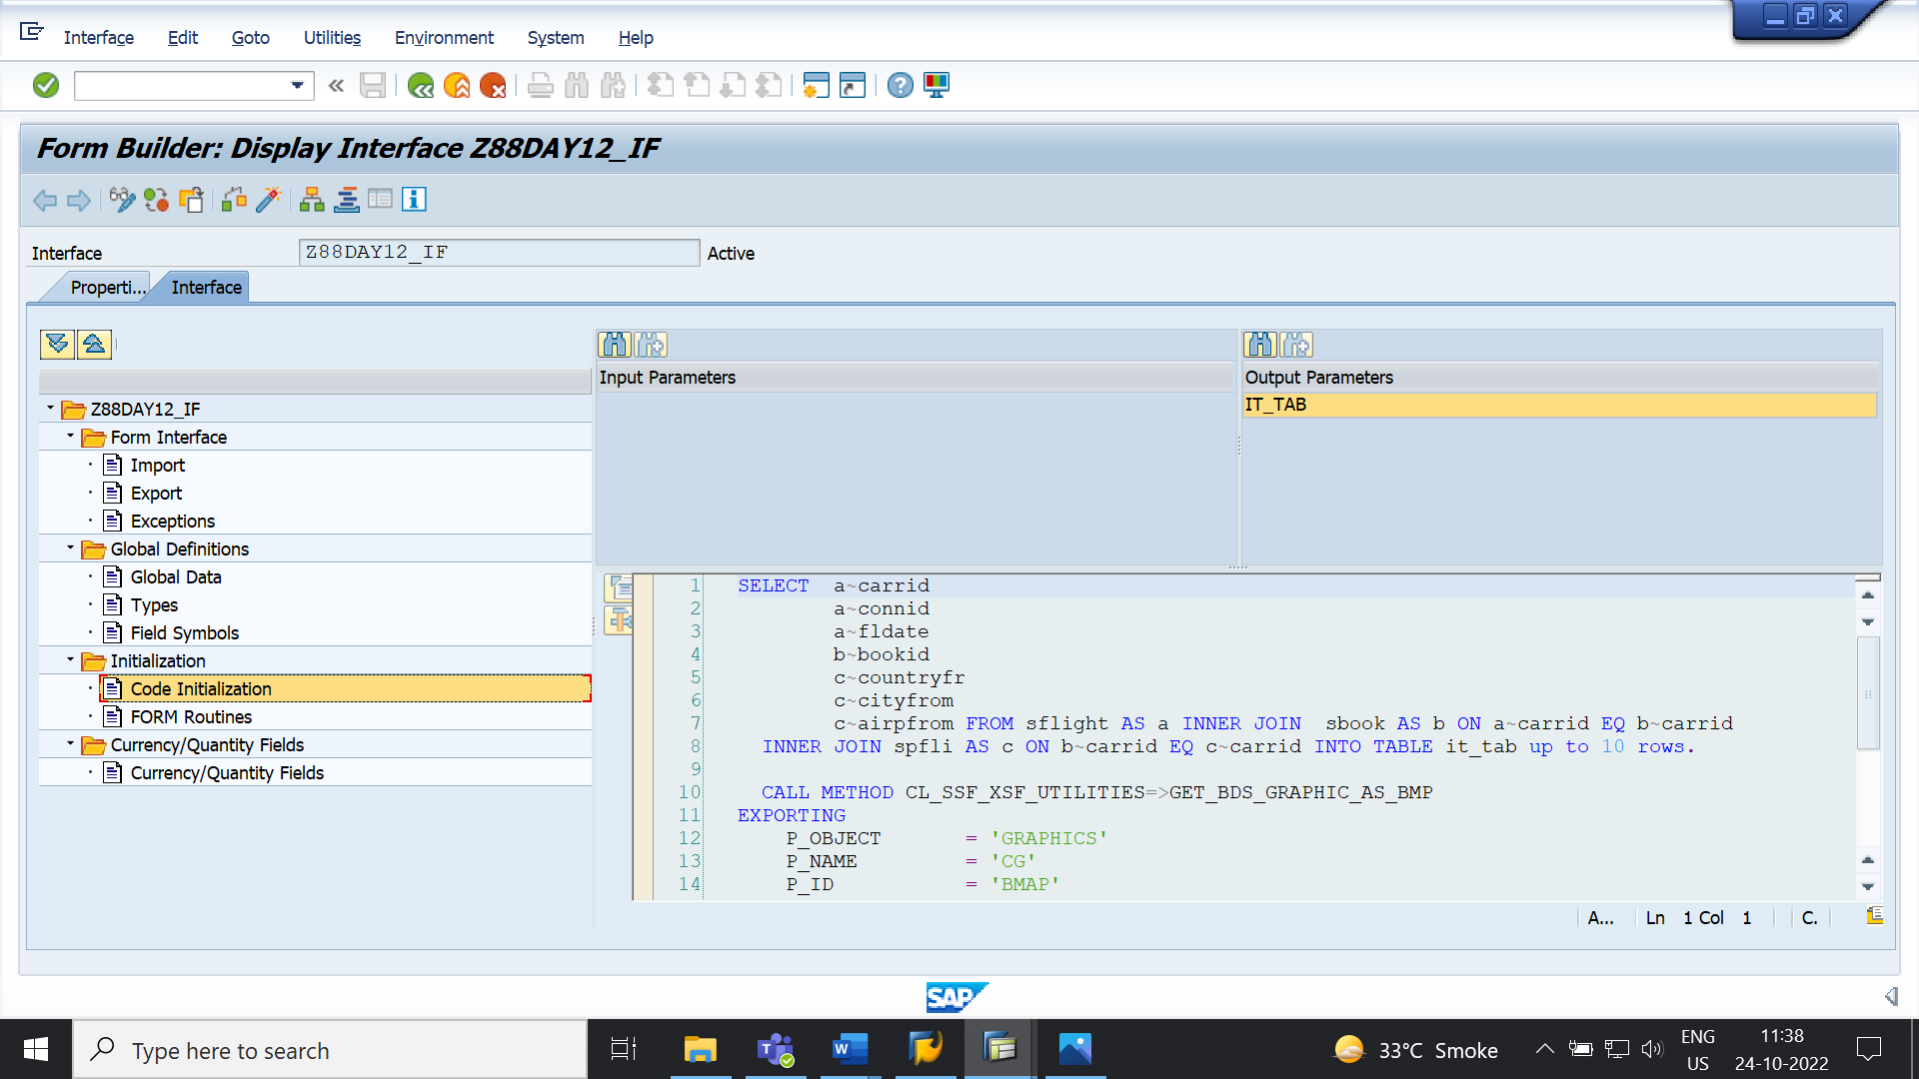

**STEP 2:** CREATE FORM.

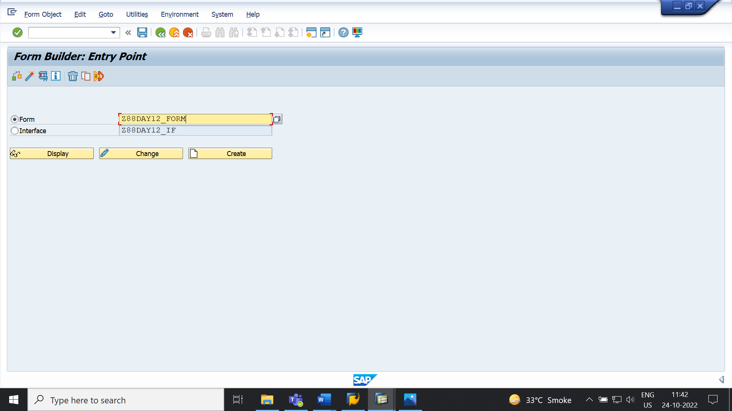

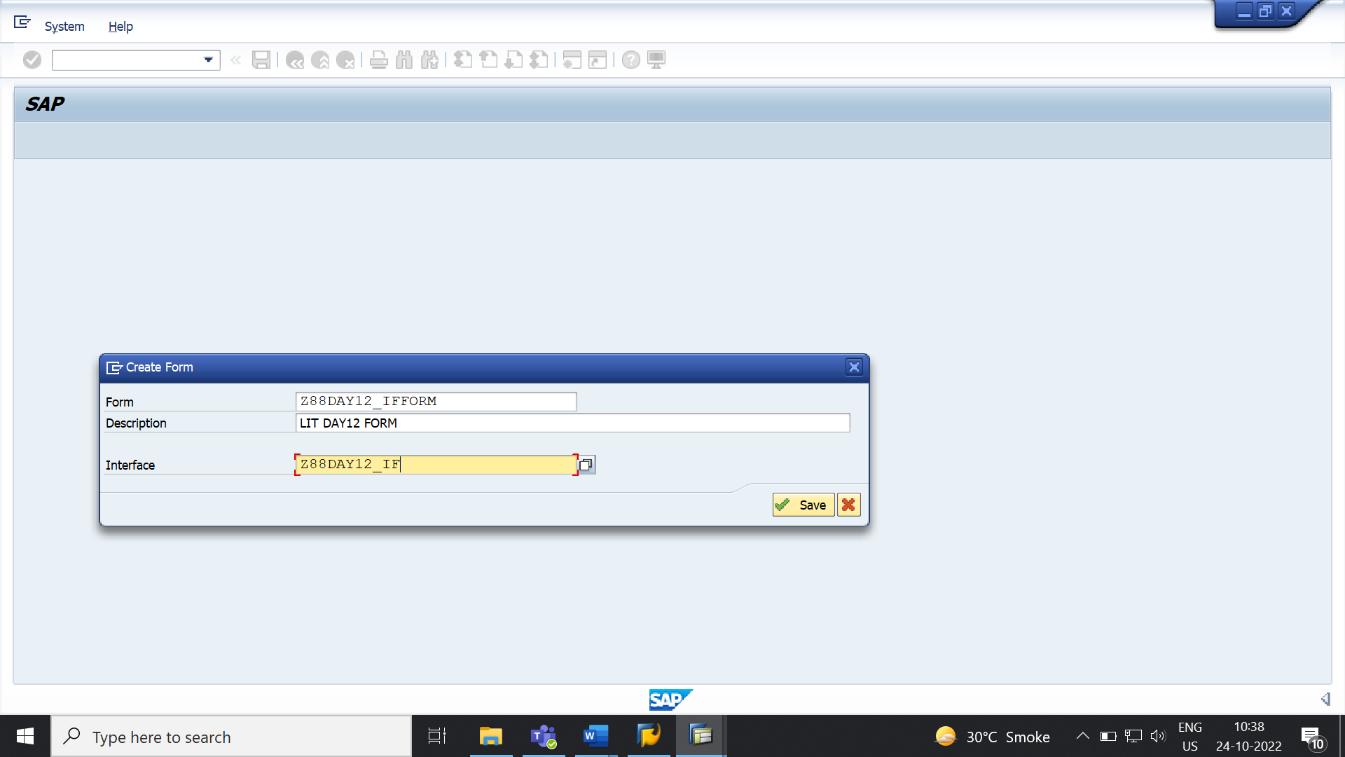

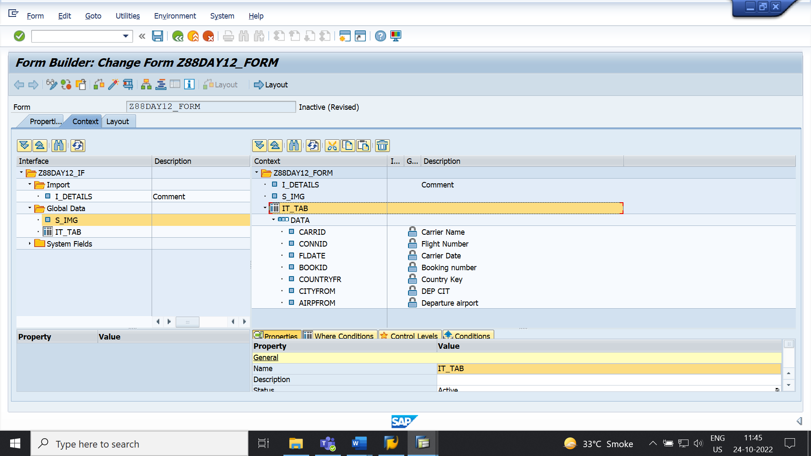

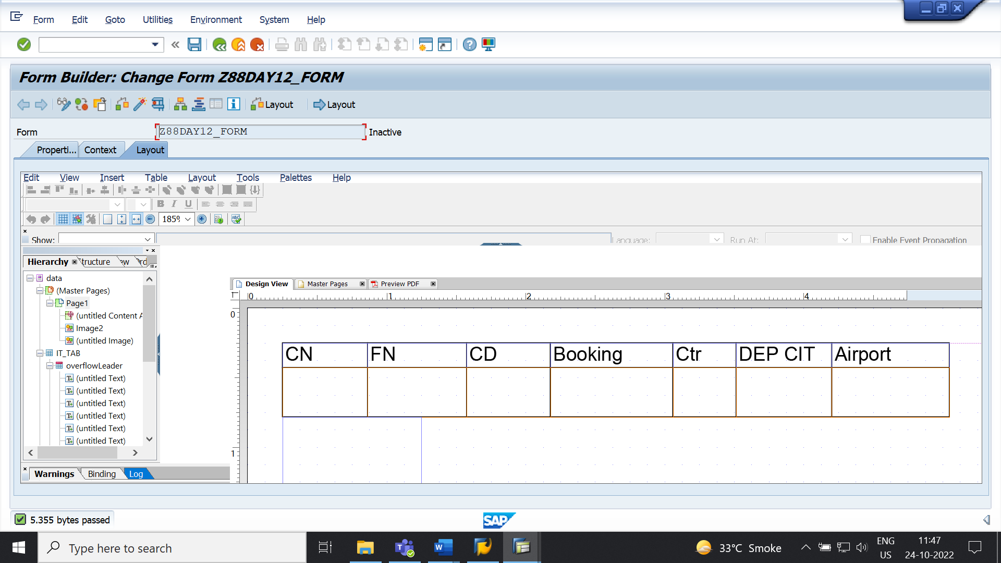

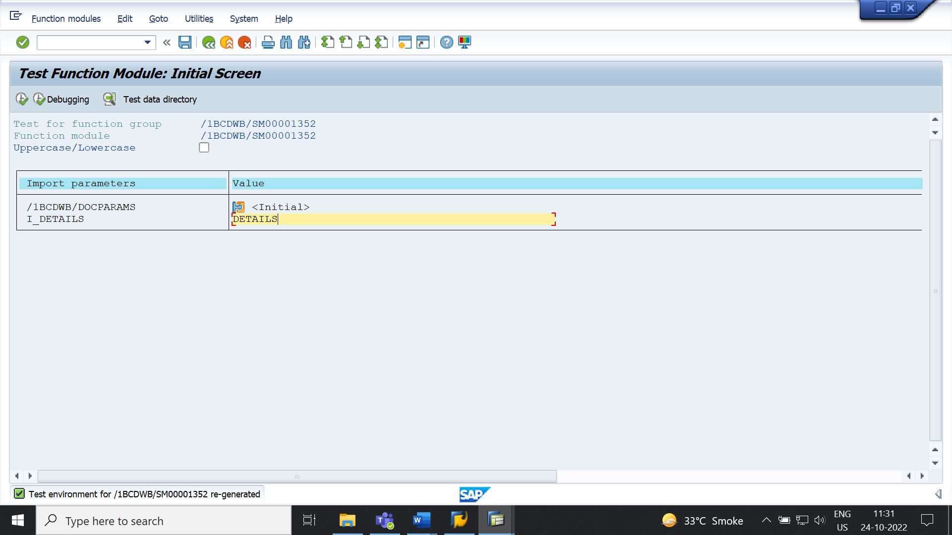

**OUTPUT:**

